cnc_rdwkcdshft

声明
/* read work coordinate shift */
[DllImport("FWLIB32.dll", EntryPoint = "cnc_rdwkcdshft")]
public static extern short cnc_rdwkcdshft(ushort FlibHndl, short a, short b, [Out, MarshalAs(UnmanagedType.LPStruct)] IODBWCSF c);

描述
读工件坐标。

参数
（1）FlibHndl 库句柄；[ in ]
（2）axis [ in ]
（3）length
（4）wkcdshft [ out ]
/* cnc_rdwkcdshft:read work coordinate shift */
/* cnc_wrwkcdshft:write work coordinate shift */
/* cnc_rdwkcdsfms:read work coordinate shift measure */
/* cnc_wrwkcdsfms:write work coordinate shift measure */
[StructLayout(LayoutKind.Sequential, Pack = 4)]
public class IODBWCSF
{
public short datano; /* datano */
public short type; /* axis number */
[MarshalAs(UnmanagedType.ByValArray, SizeConst = MAX_AXIS)]
public int[] data = new int[MAX_AXIS]; /* data */
}

函数返回值
函数运行正常返回EW_OK。

代码
CNC侧状态：
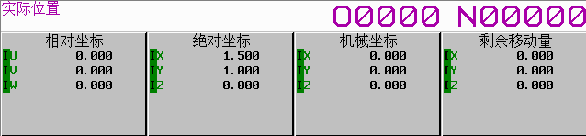
调试结果：
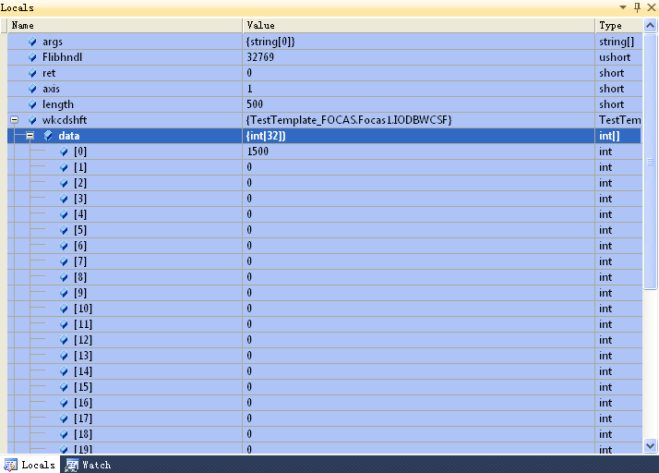
class Program
{
static void Main(string[] args)
{
ushort Flibhndl = 0;

short ret; // 返回值

// 获取库句柄 ( Ethernet )
ret = Focas1.cnc_allclibhndl3("192.168.0.224", 8193, 10, out Flibhndl);
if (ret != Focas1.EW_OK)
{
Console.WriteLine("发生异常，请检查！");
return;
}

#region cnc_rdwkcdshft

short axis = 1;
short length = 500;
Focas1.IODBWCSF wkcdshft = new Focas1.IODBWCSF();
ret = Focas1.cnc_rdwkcdshft(Flibhndl, axis, length, wkcdshft);
#endregion
}
}

